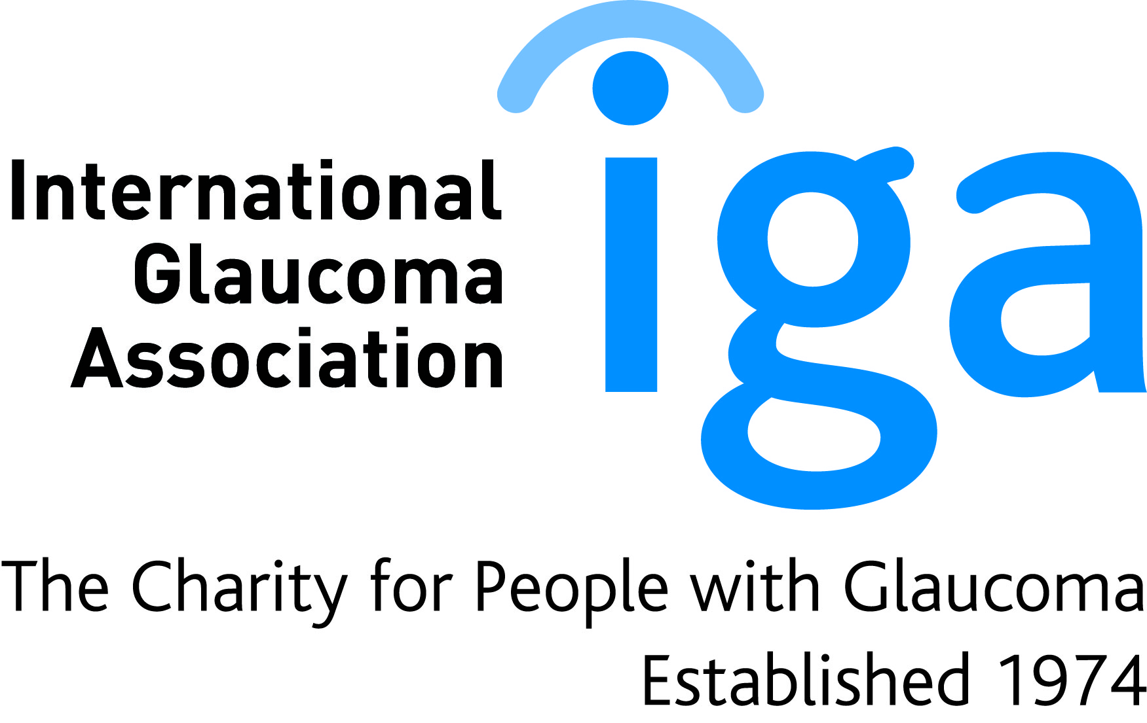
Glaucoma Support Group
Please come along and join us
Venue: Seminar Room Ground Floor
Education Centre, Southend Hospital,
Pritwell Chase, Westcliff on Sea,
Essex SS0 0RY

If you wish to attend, please register your interest
Call : 01702 435555 x 8390

Date: Thursday 15th March 2018
Time: 2.00pm to 4.00pm
Content: 2.00pm to 2.30pm:-Fiona Stephens, Glaucoma Specialist Nurse, welcome & Introduction
The role of Specialist Nurse in Ophthalmology
2.30pm-2.45pm:Subhash SutharIga: Drops- WHY HOW WHEN
2.45pm-4.00pm:Mr Simon Ruben. Consultant Ophthalmologist:
Questions and Answers
You will be most welcome.
We can help. For more information please contact
Sightline 01233 64 81 70
www.glaucoma-association.com
International Glaucoma Association,
Woodcote House, 15 Highpoint Business Village, Henwood, Ashford, Kent TN24 8DH
Administration: 01233 64 81 64 Email: info@iga.org.uk
Charity registered in England & Wales No. 274681 and in Scotland No. SC041550

